LEASE AGREEMENT

Effectively entered into on this the 1st of August of the year 2025;

An agreement, hereinafter referred to as the “Lease Agreement”, entered into by and between:

Of the one part:

⁠Mr. Graham Stewart Elliott (British ⁠Passport No. 554364138) in his capacity as Director who is appearing hereon for and on behalf of ⁠Grand Hotel Excelsior Limited (C-12837), a Maltese company having its registered office at West End Buildings, 18/2, South Street, Valletta, duly authorised, hereinafter referred to as the “Lessor”; and

Of the other part:

Mr. Mert Gulen (ID No. 0105561A) in his capacity as Director who is appearing hereon for and on behalf of Carisma Spa and Wellness International Ltd (C-51778), a Maltese company having its registered office at 114 Mert Triq il-Mizura Swieqi Malta SWQ2064, duly authorised, hereinafter referred to as the “Lessee”;

(each a “Party” and collectively referred to as the “Parties”).

The context of this Lease Agreement shall be in relation to the premises situated within ‘Grand Hotel Excelsior Malta’, located at Great Siege Road, Floriana FRN 1810, Malta (hereinafter referred to as the “Hotel”), as outlined further under clauses 1 and 2 of this Lease Agreement.

DECLARATIONS

Whereas the Lessor is willing to lease out the Leased Premises to the Lessee in accordance with the terms outlined in this Lease Agreement.

Whereas the Lessee intends to develop and operate a spa and wellness facility serving both hotel guests (In house guests) as well as guests from the local market (Maltese residents) on the Leased Premises in accordance with the terms outlined in this Lease Agreement.

Therefore, the Parties are hereby agreeing to enter into this Lease Agreement subject to the following terms and conditions:

1. LEASE AGREEMENT DOCUMENTS

1.1 The following documents shall be deemed to form an integral part of this Lease Agreement:

Annex A: Area of the Leased Premises

Annex A shall constitute the Leased Premises (as defined in clause 2 of this Lease Agreement).
Leased premises are defined on two levels. Level 1 areas to include, Pool, Spa Facilities and Dry areas as highlighted on Annex A. The Level 2 areas to include Equipment, Functional and Classes areas as highlighted on Annex A.

2. LEASED PREMISES AND POSSESSION

  - The development and operation of the Leased Premises shall constitute the area as described in the attached Annex A which is anticipated to be demolished and cleared by the Lessor and re-designed, constructed, and developed by the Lessee in collaboration with the Lessor as per Annex C and subsequently operated by the Lessee (hereinafter the “Wellness Centre” or the “Leased Premises”).

2.2 The Lessor authorises the Lessee, who accepts, to take shared possession up to as much as is required for the purposes of this Lease Agreement of the Leased Premises as from the date of commencement of the Lease Agreement which Leased Premises shall be constructed and developed in collaboration by the Parties in line with the Lessee’s designs and instruction. The Lessor, therefore, agrees that the Lessee shall be authorised to operate the Leased Premises as from the date of completion of the construction, development and re-design of the Leased Premises, and after having been inspected and accepted by the Lessee in writing, under the Lessee’s own name and brand.
3. TERM

3.1 The lease for the Leased Premises shall only be effective upon completion of the construction, development, renovation and re-design of the Leased Premises, and after having been inspected and accepted by the Lessee in writing, which commencement of the lease shall be the first day of the Lessee’s full operation of the Leased Premises and which date shall be referred to as the “Commencement Date” and shall continue to be effective for a period of five (5) calendar years from the Commencement Date (the “Initial Term”).

Upon the lapse of the Initial Term, this Lease Agreement shall renew once automatically for a period of ten (10) calendar years (the “Renewed Term”, and together with the Initial Term, the “Lease Term”) unless the Lessee provides three (3) months written notice to the Lessor of its intention not to allow this Lease Agreement to renew.

3.2 After the expiration of the Lease Term, the Lessee shall have the right of first refusal should the Lessor decide to enter into a lease agreement with any third party regarding the Leased Premises.

4. WORKS TO BE CARRIED OUT

4.1 The Lessee shall, at its sole and exclusive cost, be responsible for carrying out works as set out in Annex C. The scope of these works shall apply specifically to the following designated areas, in line with the specifications and extent described in Annex C.

4.2
The Lessor shall, at its sole and exclusive cost, be responsible for carrying out all design, construction, fit-out, furnishing, and installation works as set out in Annex C. The scope of these works shall apply specifically to the following designated areas, in line with the specifications and extent described in Annex C.

4.3 The Lessor shall, at its sole and exclusive expense, carry out the demolition and clearance of all existing partitions, equipment, fixtures, and obstructions to provide the premises in shell form, as outlined in Annex A. The Lessor shall carry out construction, renovation and installation works of the Leased Premises at its sole and exclusive expense as described in Annex C. This includes completing structural works, finishes, electrical & M&E systems, HVAC, plumbing, drainage, and fire safety systems all in compliance with local building regulations and standards. The space shall be cleared of all debris, and all necessary utility connections will be made available and functional, ready for the Lessee’s fit-out in accordance with their design plans.

4.4 For the avoidance of doubt, the total capital expenditure obligation of the Lessor in connection with the works defined under this Agreement, including but not limited to the base build scope outlined herein, shall not exceed one million two hundred thousand Euro (€1,200,000) (inclusive of VAT). The Lessor shall not be required to incur or commit to any additional costs beyond this amount, whether directly or indirectly, unless expressly agreed to in writing by both Parties.

4.5 The Parties agree that the standard of all the works and final finishings of the Leased Premises shall be of a superior standard and that any materials, finishing, sanitary ware, furniture, soft furnishings and all other improvements, movables and fixtures shall be of an aesthetic value and quality which is compatible with the overall quality standards of the Hotel. In this respect, the Lessee shall obtain the prior consent of the Lessor for the installation, use and operation of all works, equipment, improvements, movables and fixtures at the Wellness Centre.

4.6 The Lessee shall not be liable to indemnify the Lessor for the expenses incurred for the acquisition of materials, equipment, and provisions of services for the works, fixtures, finishing and any other installations carried out by the Lessor in terms of this Lease Agreement and otherwise.

4.7 Notwithstanding what has been stipulated before, the Parties hereby declare and agree that:

Should the Lessor terminate this Lease Agreement prior to the expiration of five (5) years commencing from the signing of the contract for reasons the Lessee is not responsible for, the Lessor shall be fully liable to compensate the Lessee for the intellectual property & designs (at a fixed valuation of €75,000 as at date of signing) and for any and all expenses incurred by the Lessee including for procurement, labor, development, supplies, materials, fixtures, finishings and any other improvements purchased and/or carried out during this period to the Leased Premises in terms of this Lease Agreement.

Should the Lessor terminate this Lease Agreement during the period between the first day of the sixth (6) year to the last day of the eighth (8) year commencing from the first day of the full operation of the Leased Premises by the Lessee , the Lessor shall compensate the Lessee half (50%) of the intellectual property & designs (at a fixed valuation of €75,000 as at date of signing) and for any and all expenses incurred by the Lessee including for procurement, labor, development, supplies, materials, fixtures, finishings and any other improvements purchased and/or carried out during this period to the Leased Premises in terms of this Lease Agreement.

Should the Lessor terminate this Lease Agreement during the period between the first day of the ninth (9) year to the last day of the tenth (10) year commencing from the first day of the full operation of the Leased Premises by the Lessee , the Lessor shall indemnify the Lessee twenty-five per centum (25%) of the intellectual property & designs (at a fixed valuation of €75,000 as at date of signing) and for any and all expenses incurred by the Lessee including for procurement, labor, development, supplies, materials, fixtures, finishings and any other improvements purchased and/or carried out during this period to the Leased Premises in terms of this Lease Agreement.

For avoidance of doubt, the Parties agree that the Lessee shall not be entitled to any compensation where this Lease Agreement is terminated due to the Lessees fault or for any reason attributable to the Lessee.

5. RENT AND OTHER CONSIDERATIONS DUE

5.1 Rent payable by the Lessee to the Lessor for the Leased Premises shall be as follows:

- for the first five (5) year period commencing from the first day of the full operation of the Leased Premises by the Lessee: no rent shall be payable;
- for the next five (5) year period commencing from the first day of the sixth (6th) year of full operation of the Leased Premises by the Lessee: thirty thousand Euro (€30,000) per annum; and
- for the final five (5) year period commencing from the first day of the eleventh (11th) year of full operation of the Leased Premises by the Lessee: fourthy thousand Euro (€40,000) per annum.

5.2 The rent shall be paid without any deduction or set-off, quarterly and in advance. Value added tax (“VAT”) is to be added to each payment.

5.3 The Parties agree that, in the event the Hotel is inoperative, including as a result of undergoing any works or construction in or around the Hotel, that result in more than fifty per cent (50%) of the Hotel’s rooms being unavailable for booking or utilisation by the general public, the rent payable by the Lessee to the Lessor for the duration of inoperability of the Hotel shall be reduced to fifty per cent (50%) of the rent payable as per clause 5.1, as applicable.

5.4 For the avoidance of doubt, the Parties agree that should the Hotel be closed by the Lessor for any reason and for any period of time the rent due by the Lessee to the Lessor for that period of time shall not be due and this unless the Lessee is able and chooses to nonetheless proceed with operating the Lease Premises during such period of the Hotel’s closure.

5.5 Revenue directly referred by the hotel staff employed by the Lessor (reception, front office, concierge) or from Lessor’s booking systems (spa packages sold by Lessor on Online Travel Agency (OTA) or hotel booking platform) shall be shared as follows:
- Carisma Spa Ltd: 90%
- Grand Hotel Excelsior Malta: 10%

To ensure transparency in the revenue-sharing arrangement, the Lessor and Lessee agree that any revenue derived from bookings made through hotel staff referrals or through the Hotel’s booking platforms, including Online Travel Agencies (OTAs), shall be tracked and reported on a quarterly basis. The revenue share distribution will be based on the net revenue, after any applicable taxes and fees, and will be reconciled and paid to the respective parties within 30 days following the end of each quarter.
6. LIMITATION OF USE

6.1 The Lessee’s commercial activities intended to be conducted from within the Wellness Centre shall comprise of services including, but not limited to, manicure, pedicure, acupuncture, massage services, facial services, beauty treatments, medical aesthetics and dermatology doctor services, nutritionist services, doctor and doctor related services, spa retreats, anti-aging and anti-aging related services, facility access, gym access, group class passes, personal training, group fitness classes, spa boutique, yoga, Pilates, Lagree, and other fitness-related activities, private event hosting, and fitness seminars, as well as cafe services including service of food, and drinks subject to the Lessee obtaining and having at all times the necessary licences, permits, and authorisations from the competent authorities to conduct any of the intended commercial activities and services from within the Wellness Centre.

6.2 The Lessee’s commercial activities listed in the preceding clause may be conducted by any of the companies owned by the ultimate beneficial owners of Carisma Spa & Wellness International Ltd. or forming part of the same group of companies to which the Lessee belongs, and any performance of any such activities shall not be restricted by any rights of sub-lease.
6.3 To ensure the Lessee's operations are not undermined by competing services within the Hotel, the Lessee shall have exclusive rights to operate a wellness center on the Leased Premises. The Lessor shall not allow any similar wellness or spa-related services to be operated by third parties within the Hotel or any adjacent areas throughout the Lease Term, unless agreed upon by the Lessee in writing. This exclusivity extends to the use of the space for wellness and spa treatments, including but not limited to massage, fitness, beauty, and wellness services.

7. OBLIGATIONS OF THE LESSOR

7.1 The Lessor shall provide a water mains and electricity supply up to the perimeter of the Leased Premises. Upon the successful development, completion and full operation of the Leased Premises by the Lessee, until the termination of this Lease Agreement, all electricity consumption by the Lessee related to treatment rooms shall be metered separately by means of sub-meters and shall be chargeable to and payable by the Lessee. Furthermore, electricity, water, and any other utility consumption from the common areas shall be chargeable to and payable by the Lessor.

7.2 All ordinary maintenance and repairs, in so far as practicable, shall be carried out by the Lessor through the Hotel’s maintenance team. Extraordinary repairs and works shall also be carried out and borne by the Lessor. The Lessor shall carry out any repairs on equipment purchased as new and unused by the Lessee for the Wellness Centre and the operation of its commercial activities and services. All equipment must be covered by the appropriate guarantee or warranty (in terms of Maltese law). For the purposes of avoidance of damage to or malfunction of the equipment, the Lessee shall indicate to the Lessor any periodic maintenance to, and inspection of, the equipment as is diligently necessary unless such service to the equipment is provided for under the equipment's guarantee or warranty.

7.3 The Lessor shall include the Wellness Centre in its Public Liability Insurance.
7.4 Throughout the term of this Lease Agreement, the Lessee’s employees performing their employment at the Wellness Centre shall, upon presentation of appropriate identification, be entitled to free lunch and dinner meals available at the staff canteen within the Hotel.

7.5 A receptionist will be employed by the Lessee to oversee the Wellness Centre and common areas during Wellness Centre opening hours and to provide towels to the Hotel guests. The Lessor shall provide the Lessee with free laundry services for the towels and robes used at the Wellness Centre.

7.6 The Lessor shall ensure that the common areas of the Hotel, and the fitness area to be cleaned by the Lessor at least three times daily.

7.7 The Lessor hereby covenants to provide, at no additional charge to the Lessee or the Lessee's patrons, a minimum of three (3) hours of parking per Wellness Centre guest per visit.

8. OTHER OBLIGATIONS OF LESSEE

8.1 The Lessee shall, at all times, ensure that the standard and quality of operation and provision of the commercial activities and services from the Wellness Centre are equal to or higher than the standards of operation and service expected.

8.2 The Lessee shall ensure that in addition to the quality and standards expected, all relevant codes, rules, policies, and regulations established from time to time by the Lessor in relation to the Hotel, or the group of companies the Lessor forms part of, are complied with at all times.

8.3 The Lessee shall operate the Wellness Centre during the hours that it deems fit, provided that the Wellness Centre is open on a daily basis, and further provided that the opening hours shall be in compliance with law and regulation.

8.4 The Lessee shall ensure that any supplies or goods received, including construction materials relating to the preparation and design up until the Commencement Date, at the Wellness Centre are solely delivered through the access from the “back-of-house” security entry of the Hotel.

8.5 The Lessee shall conduct its activities at its own risk and expense without any cost to the Lessor. All losses, dues, obligations, and any other liabilities incurred by the Lessee shall remain the sole and exclusive responsibility of the Lessee.

8.6 The Lessee shall not allow or permit any nuisance or any act that disturbs or may disturb any one or more of the guests and, or the operation of the Hotel.

8.7 The Lessee shall obtain and maintain at all times during the duration of the lease all permits, licences, and any other authorisations required from the competent authorities for the operation of the Wellness Centre and all commercial activities and services provided therefrom at its sole expense and responsibility.

8.8 Upon the expiry of the Lease Term or any earlier termination of the lease in terms of this Lease Agreement or Law, any permit, licence, and any other authorisation issued on the Lessee, if any at all at that moment in time, shall be transferred onto the Lessor without any right of compensation competent to the Lessee.

9. EVENTS OF DEFAULT AND CONSEQUENCES

9.1 The occurrence of any one or more of the following events in respect of either Party (the Lessee or the Lessor) shall constitute a material breach of this Lease Agreement, entitling the other Party to terminate the Agreement with immediate effect by written notice:

- The Lessee vacating or abandoning the Leased Premises prior to the expiration of the Lease Term;
- (a) The making of any general assignment or general arrangement for the benefit of creditors;
(b) The commencement of any voluntary or involuntary proceedings for bankruptcy, insolvency, judicial composition, administration, or liquidation by or against either Party, which are not dismissed or discharged within thirty (30) days;
(c) The appointment of a receiver, trustee, administrator, or similar officer over a substantial part of the assets of either Party;
(d) The inability of either Party to pay its debts as they fall due or the admission of such inability in writing.
In such event, the non-defaulting Party shall have the right to seek all remedies available at law or in equity, including but not limited to compensation for losses or damages arising from such termination.

- the Lessee/Lessor, in particular its directors and company secretary, are convicted or plead guilty to any criminal offence, except offences whereby such conviction or admission shall be punishable by a fine (multa or ammenda);

- the Lessee fails to effect the rent payments punctually or within a period of six (6) months from when they are due in the instances when they are due by the Lessee to the Lessor in advance.

The occurrence of a material default and/or breach of this Lease Agreement by either the Lessee or the Lessor, the non-defaulting party shall be entitled to, immediately and without notice, rescind their obligations under this Agreement and/or terminate this Agreement ipso iure, and the Leased Premises and to claim full compensation for any damages, losses, or loss of business suffered, in accordance with applicable law.

9.2 If, for any reason any part or all of the premises of the Hotel which has not been agreed to by the Parties is demolished or the Lessee is informed of any plan/s to demolish any part or all of the premises of the Hotel which has not been agreed to by the Parties, or the Hotel is abandoned, or the Hotel is inoperative, including as a result of undergoing any works or construction in or around the Hotel, that result in one hundred per cent (100%) of the Hotel’s rooms being unavailable for booking or utilisation by the general public, which demolition, abandonment or inoperability may affect any investment made by the Lessee or the regular operation of the Wellness Centre by the Lessee in accordance with this Lease Agreement, for the duration of the Lease Term, the Lessee shall be entitled to terminate this Lease Agreement effective immediately, including any of the Lessee’s obligations envisaged by this Agreement pertaining to the Leased Premises, as applicable, by providing written notice to the Lessor, which notice and/or termination shall not result in any liability or claim of liability by the Lessor to the Lessee under this Lease Agreement. Any such termination shall be, without prejudice, to clauses 4.5 and 10.3 of this Lease Agreement.

Moreover, the Lessor shall provide the Lessee with a copy of any relevant and/or necessary permits required in relation to the Leased Premises, upon reasonable request of the Lessee.

9.3 If, for any reason, any investment made by the Lessee to or in the Leased Premises is impacted or damaged as a result of the demolition, building, construction, development, or otherwise, of the premises of the Hotel, the Lessor shall be fully liable to compensate the Lessee for all the expenses incurred by the Lessee for the works, fixtures, finishings and any other improvements carried out to the Leased Premises which were impacted or damaged as a result of the demolition, building, construction, development, or otherwise by the Lessor or third-parties, as applicable, in terms of this Lease Agreement.
9.4 In the event of a sale or transfer of ownership of the Hotel, whether in whole or in part, to any third party:
i. all rights and obligations of the Lessor under this Lease Agreement shall automatically transfer to and be binding upon the new owner, and shall remain attached to the Hotel; and
ii. all rights and entitlements of the Lessee under this Lease Agreement shall continue uninterrupted and shall be enforceable against the new owner.
Any failure to effect such transfer of obligations shall constitute a material breach of this Lease Agreement by the Lessor and/or the new owner.
The Lessor shall be required to notify the Lessee in writing of any intended sale or transfer of the Hotel at least three (3) months in advance of completion. Upon such notification, and for a period of twelve (12) months following the effective date of transfer of ownership (the "Probation Period"), the Lessee shall have the right to terminate this Lease Agreement at its sole discretion, without penalty or liability, by giving one (1) month’s written notice to the new owner and/or the Lessor.
For the avoidance of doubt, during and after the Probation Period:
i. The new owner shall be bound by and honour all terms and conditions of this Lease Agreement, as originally concluded with the Lessor;
ii. The new owner shall have no right to unilaterally alter or renegotiate any terms of the Lease Agreement without the express written consent of the Lessee;
iii. Should the new owner seek to terminate this Lease Agreement prior to its expiry, it may seek to agree with the Lessee on fair and mutually acceptable compensation for early exit.
9.5 In the event of a change in the shareholding structure or control of the Lessor, the obligations of the Lessor under this Lease Agreement shall remain fully valid, binding, and enforceable against the Lessor, irrespective of any such change.

10. VACATION UPON EXPIRY / TERMINATION

10.1 Upon expiration of this Lease Agreement, or termination of the Lease Agreement triggered by the Lessee, and without prejudice to the above clause 9, the Lessee shall vacate the Wellness Centre and shall clear all its effects limitedly to movables or semi-movables, provided the removal of which does not cause damage to the Wellness Centre or the Hotel, from the said Wellness Centre within fifteen (15) days following the expiry of the Lease Term, exclusive of Sundays and public holidays.

Notwithstanding the above, in the event of a termination of this Lease Agreement triggered by the Lessor, the Lessee reserves the right to vacate and clear its effects at its sole discretion, when and as it deems fit, without being liable for any damage to the Leased Premises.

10.2 Upon expiration of this Lease Agreement, or termination of the Lease Agreement triggered by the Lessee, and without prejudice to the above clause 9, the Lessee shall have the right to remove all equipment, fixtures, and improvements, at its own expense, without being liable for any damage to the Leased Premises, provided that such removal is done within thirty (30) days after termination (exclusive of Sundays and public holidays) and does not impair the structural integrity or safety of the premises.

Notwithstanding the above, in the event of a termination of this Lease Agreement triggered by the Lessor, the Lessee reserves the right to remove all equipment, fixtures, and improvements at its sole discretion, when and as it deems fit, without being liable for any damage to the Leased Premises.

11. INDEMNITY AND INSURANCE

11.1 The Parties shall hold each other harmless and fully indemnified against any claims as well as any such damages, costs, demands and expenses which may be brought against, suffered, or incurred by the other Party, including all legal, professional and other expenses incurred as a result of the operation of the Wellness Centre by the Lessee.

11.2 The Lessee shall take out and maintain an adequate insurance policy, to be approved by the Lessor, covering all commercial activities and services to be carried out by the Lessee at the Wellness Centre.

12. INTEREST ON PAST DUE OBLIGATIONS

12.1 Any amount due by the Lessee to the Lessor not paid when due shall bear interest in terms of Title II Sub-title IA of Cap. 13 of the Laws of Malta, in any case not being less than 3% per annum. Payment of such interest shall not excuse or release the Lessee from any default otherwise due under this Lease Agreement and is without prejudice to any of the other provisions under this Lease Agreement or any actions competent to the Lessor at Law.

13. APPLICABLE LAW AND DISPUTE RESOLUTION

13.1 This Lease Agreement is governed by Maltese law.

13.2 In the event of any dispute arising in any manner out of this Lease Agreement, the Parties agree to revert the dispute to the exclusive jurisdiction of the Courts of Malta.

14. NOTICE

14.1 Any notice required or permitted to be given in accordance with this Agreement shall be in writing and may be served personally, by email, or by registered mail, return receipt requested, addressed to the Lessor or to the Lessee respectively at the hereunder addresses. Such notices shall be deemed effective upon the date of delivery.

14.2 The notification addresses of the Parties are the following:

Lessor:
Address: West End Buildings, 18/2, South Street, Valletta
Telephone: +63 977 181 8330
E-mail: grahame@ewil.net

Lessee:
Address: 114 Mert Triq il-Mizura Swieqi Malta SWQ2064
Telephone: +356 9950 3020
E-mail: mert@carismaspa.com

or to such other addresses as either of the Parties may hereafter agree to in writing.

15. WAIVERS

15.1 No waiver by either Party of any provision hereof shall be deemed a waiver of any other provision hereof or of any subsequent breach by either Party of the same or any other provision. Either Party’s consent to or approval of any act shall not be deemed to render unnecessary the obtaining of the Lessor’s consent to or approval of any subsequent act by the Lessee. The acceptance of rent by the Lessor shall not be construed as to constitute a waiver or tacit acquiescence of any preceding breach by the Lessee of any provision hereof, any interest accrued left unpaid, and, or the failure of the Lessee to pay the particular rent so accepted.

16. FORCE MAJEURE

16.1 If either Party is prevented from doing, accomplishing or performing any act or thing required of either Party under the terms of this Lease Agreement due to causes beyond either Party’s reasonable control (including, but not limited to, acts of God, war, civil commotion, labour disputes, strikes, fire, flood or other casualty, shortages of labour and material unless through the Party’s negligence or incompetence, government regulation or restriction or weather condition), the time provided in this Lease Agreement for doing, accomplishing or performing such act or thing shall be extended in order to provide either Party with the same number of days to accomplish or perform such act or thing after termination of such causes as either Party would have had in the absence of such causes.

17. AGREEMENT, SEVERANCE AND INTERPRETATION

17.1 This Lease Agreement supersedes any and all agreements between the Parties relating to the subject matter herein, whether verbal and in writing.

17.2 If any provision of this Lease Agreement or any part thereof is rendered void, unlawful, or unenforceable, it shall be void, unlawful and unenforceable to that extent only and the remainder of this Lease Agreement shall remain in full force and effect.

17.3 Headings in this Lease Agreement are for reference purposes only and shall not affect its interpretation.

17.4 This Lease Agreement records the full understanding between the Parties hereto and shall only be amended by a further written agreement signed by the authorised representatives of the Parties.

17.5 This Lease Agreement may be executed in two or more counterparts, each of which shall be deemed an original, but all of which together shall constitute one and the same instrument.
17.6 A signed copy of this Lease Agreement transmitted by digital signature shall be deemed to have the same legal effect as delivery of an original executed copy of this Lease Agreement for all purposes.

[SIGNATURES OVERLEAF]

Signed:

___________________________
Graham Stewart Elliott
Director
Duly authorised for and on behalf of
⁠Grand Hotel Excelsior Limited (C 12837)

___________________________
Mert Gulen
Director
Duly authorised for and on behalf of
Carisma Spa and Wellness International Ltd (C 51778)

Annex A. Area of the Leased Premises
(as defined in clause 2 of this Lease Agreement)
Designated areas including Pool Area, Spa Area, Dry Area, Gym, Class
Level 1
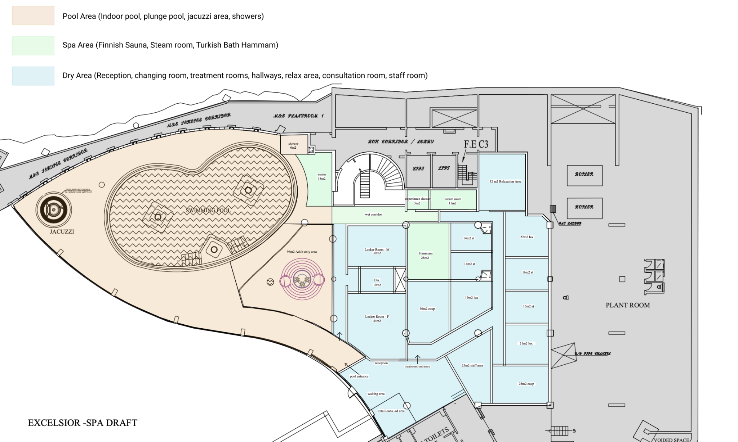
Level 2
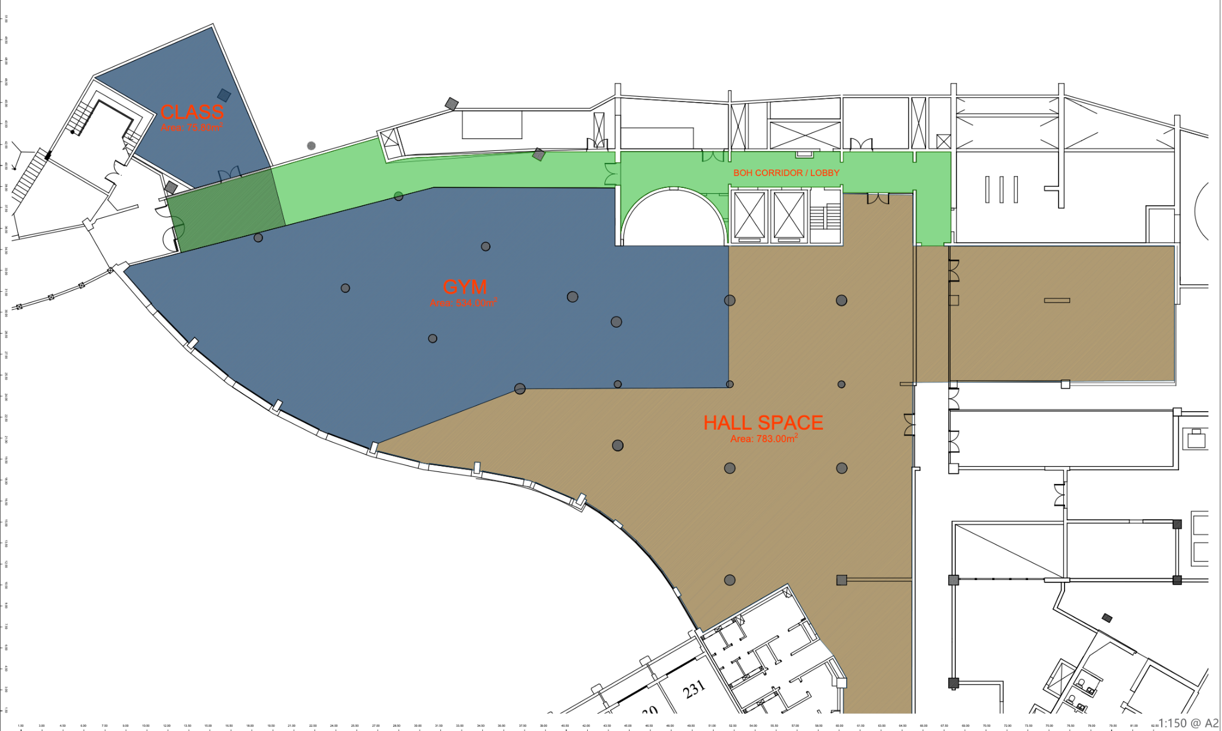
The above designs drawn up for the Leased Premises are an initial draft provided by the Lessee, which may be subject to further changes.
Annex B. Operational terms

The Lessor shall provide the Lessee’s employees performing their employment at the Wellness Centre the same discounts that the Lessor’s employees enjoy on purchases made from Hotel outlets. Similarly, the Lessee shall extend to the Lessor’s employees performing their employment at the Wellness Centre the same discounts that the Lessee’s employees enjoy on purchases made from the Wellness Centre.

The Lessee's directors shall be entitled to free meals available at buffet restaurants within the Hotel premises. Similarly, directors of the Lessor shall be entitled to a free treatment each month.

From the Commencement Date up until the termination of this Lease Agreement, the Lessee shall be allowed to market, promote and/or advertise the Wellness Centre and the Lessee’s commercial activities and services within the Hotel. The Lessor shall not charge the Lessee for any of these marketing, promoting and/or advertising activities.

The Lessee shall be allocated an exclusive space within the Hotel's lobby wherefrom it shall be allowed by the Lessor to place an information desk and display any advertisements concerning the Wellness Centre and the commercial activities of the Lessee.

The Lessee shall have the right to place promotional leaflets and informative marketing printed material in common areas of the Hotel.
The Lessee shall have the right to collaborate with reception staff to share welcome offers and informational leaflets with guests at check in.

The Lessee shall have the right to run digital marketing campaigns promotional premises to the local market to attract outside guests to the hotel and the premises.

The Lessee shall have the right to integrate into the existing signage at the Hotel navigation boards with clear directions to the Wellness Centre.

The Lessee’s employees shall be allowed to promote the Wellness Centre and the Lessee’s commercial activities and services in the Hotel’s lobby, pool deck, and common areas.

The Lessee shall have the right to coordinate with Hotel reception and housekeeping staff to distribute promotional leaflets and informative marketing materials in the Hotel rooms.

The Lessor acting through the Hotel's sales and marketing department shall promote the Wellness Centre via digital, social and physical marketing channels
The Lessor shall integrate a dedicated webpage to the Wellness Centre on the Hotel's website and mention the Wellness Centre on the informational welcome emails. Such content is to be crafted in collaboration with the Lessee and include backlinks to the Lessee’s web assets.

Should the Hotel have a guest in-room television and lift television systems, the Lessor undertakes to promote the Lessee’s Wellness Centre commercial activities and services through these systems

The Lessor shall allow, space and availability permitting, access to use a meeting room inside the hotel once per month for management meetings

The Lessee’s brand and name, including trademarks and logos, shall not be used by the Lessor or any third party in connection with the Hotel or its services without the prior written consent of the Lessee. The Lessee shall have full control over the branding, advertising, and marketing materials related to the Wellness Centre.

Annex C.
Design, Procurement & Development Schedule for level 1 & 2
Lessor's Scope:
Design Management (Pool area)
Demolition & clearance to shell form
All structural works
MEP, lighting, power & sounds on both floors
Finishing
Landscaping
Pool & wet area civil works incl. indoor pool, plunge pools, jacuzzis and showers
Core infrastructure
Wet area furniture and elements
Lessee's Scope:
Design management (Others)
Spa & gym interior fit-out furniture
Wellness equipment installation
Custom furniture, FF&E
Spa Facilities (Sauna, Steam room, Hammam)
Spa experience features (acoustics, scent)
Operational tech & IT infrastructure
Fitness space fit-out and equipment installation
Staff spaces, access control, POS systems
Lounge and retail space fit-out in gym area

